Latest News: 9th September 2020

A One Minute Short Read by Project Trustee Mike Fonfe´

Swimming: Muscle Memory & Humphrey’s Law

It was The English psychologist George Humphrey (1889–1966), who propounded his 1923 Law in verse. When he wrote it, he went on to say: "It is a most psychological rhyme. It contains a profound truth which is illustrated daily in the lives of all of us". ^{[7]}

Humphrey's Law states: “Once performance of a task has become automatized, conscious thought about the task, while performing it, impairs performance.” He illustrated this in two famous poems:

A centipede was happy – quite!
Until a toad, in fun, said:
"Pray, which leg moves after which?"

This raised her doubts to such a pitch,
She fell exhausted in the ditch
Not knowing how to run.

And, in a variation of the same theme:

A spider met a centipede while hurrying down the street,
"How do you move at such a speed, with all so many feet?"

"I do not have to contemplate to keep them all in line,
But, if I start to concentrate, they're tangled all the time!"

What does Humphrey’s Law mean for learning to swim?

Quite simply, if you learn, early-on, to throw your arms vigorously ‘Over the Rainbow’, kick your knees-bent coming out the water or froth foam with your feet, as well as throwing your head and shoulders about to the front to lift your head out of the water to breathe, you will have already set in train seriously instinctive muscle memories. Not only is such swimming a blaze of wasted energy and very tiring, it is big on water drag and small on propulsion, reducing your chances of surviving in a drowning situation severely.

Worse still are pool lengths of furious kicking, head-up, facing forward, clutching a kick float that masks natural buoyancy and creates an unnecessary float-aid dependency. By constantly refreshing such negative achievements, muscle memory is thoroughly reinforced. All these activities waste energy that make for a poor contribution to efficient movement and eat heavily away at survival prospects in a crisis.

Further down the learn-to-swim process, where we are trying to develop efficient, effortless, streamlined swimming, there is a years-long battle ahead to overcome and unlearn these now deeply buried unconscious muscle memories. Add to that the fact that treading water consumes more energy than straight front crawl or breaststroke, one wonders why it is given so much prominence.

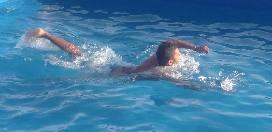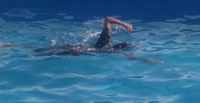

Do it Once; Do it Right. Why do we have to UNLEARN Bad Muscle Memory to Get Good?
[Images 14 & 15]
The absolutely key skill to guarantee aquatic survival is not swimming, but floating: the ability to rest on the surface of the water, face-up on the back and breathe. This position demands no energy; however, achieving the necessary balance by correct positioning of the head, spine, legs and arms and controlling buoyancy through regulated breathing, all need to be learned in order to acquire that essential muscle memory. Once achieved, consistently being able to float horizontally on water indefinitely without having to think about it is as easy as standing upright on land. The bonus of energy-free flat surface floating is that it is then a breeze to move forward progress to effortless, streamlined, minimal energy-expenditure propulsion, efficient swimming, flat on the surface.

So, not introduce muscle memories that have to be unlearned,
- they’ll get tangled all the time !

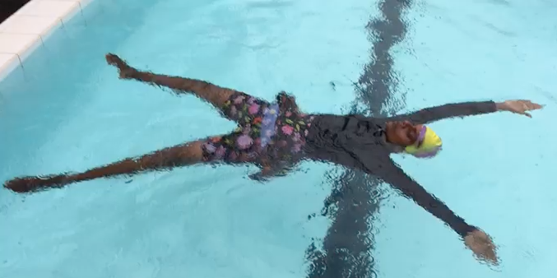
The Totally Relaxed Energy Expenditure-Free Face-up Star Float
[Image 16]
If we want swimming lessons to prevent drowning, floating should be the absolutely first skill to be learned until, in Humphrey’s terms, it is so well mastered that it becomes effortlessly instinctive. Remember, people don’t drown because they cannot swim; they drown because they cannot breathe. So, for absolute survival, Float and Breathe First, then Swim.

And bin those endless lengths behind a kick float banish bad muscle memory for ever.

Source [7] Roeckelein, Jon E. (1998). Dictionary of Theories, Laws, and Concepts in Psychology ([Online-Ausg.] ed.). Westport, Conn.: Greenwood. p. 447. ISBN 978-0-313-30460-6.

